# Pre-Processing

1. File > Import Data > using eeglab functions > from .xdf file

1. Edit – Channel Locations, click through and hit ok (confirm the GUI has ‘yes’ for channel locations)
   1. Rename A2 channel type as “Ref”, Exg 1 and2 as “EMG”, ACC 22-24 as “ACC”, Packet Counter and Trigger as “Misc”
2. Plot the data:
   1. Plot -> data (scroll)
3. Filter data:

* 1. Tools > Filter Data > Basic FIR filter
     1. Highpass: 0.1
     2. Lowpass: 50
     3. Channel type(s): EEG
     4. A screenshot of a computer

        AI-generated content may be incorrect.
     5. Save as: cam_###_block#_filt

1. Edit -> select data. Select … remove these channel types and select ACC and Misc

* 1. Make sure you select the box to remove them
  2. Save as: cam_###_block#_chansremoved

1. Plot the data:
   1. Plot -> data (scroll)
   2. Data should be on a much smaller scale with ACC channels removed.
2. Tools -> Re-reference the data

* 1. Compute average reference
  2. Rename as: cam_###_block#_reref

1. Run ICA

* 1. Tools > decompose data by ICA
  2. Infomax picard
  3. 'maxiter', 512, 'mode', 'standard'
  4. Check recorder components by variance
  5. Use only channel types: EEG

1. Tools > Classify components using ICLabel>Label Components

* 1. Select which version of ICLabel to use: Default
  2. 1:19, [2,50]
  3. Look for alpha and beta peaks by scrolling through the pics
     1. alpha (10 Hz) and beta (13-30 Hz).
     2. 0-10Hz = EKG heat map around the ears
     3. 0-100 Hz = muscle, looks like EMG
     4. Don’t want to remove more than 10 components
     5. It it’s less than 1%, keep it unless it’s super clear what it’s coming from (muscle)
  4. Record the components you would like to remove in the excel sheet.

1. Tools>remove components
   1. Save as: cam###_block#_postica
2. Interpolate if necessary (artifact rejection in ERPlab should catch this if it’s an issue)
   1. If one or more EEG channels are identified as bad, they should be interpolated before epoching using EEGLAB. This is necessary if:
      1. The channel shows **constant high noise** across all trials.
      2. The channel has been completely **flatlined** or disconnected.
      3. The channel exhibits **excessive drift** that is not present in neighboring electrodes.
   2. **Steps to Interpolate:**
      1. Visually inspect the data **after ICA removal** and before event-based epoching.
      2. Identify bad channels:
         1. Use **Plot > Channel Data (Scroll)** to identify channels with excessive noise or missing data.
         2. Use **Tools > Spectral Analysis** to check if a channel has abnormally high power in certain frequency bands.
      3. If necessary, interpolate using:
         1. Tools > Interpolate Channels in EEGLAB.
         2. Select the bad channel(s), and EEGLAB will use spherical spline interpolation.
         3. Record which channel was interpolated in the spreadsheet
      4. Save the dataset as cam###_block#_interp.

# Setting up ERPLab

1. Creating an EventList
2. ERPLab>EventList>Create EEG Event List

* 1. Helpful Hints: bin numbering cannot start at 0. Bins can be created however you want them but it is helpful to have this completed prior to this step because it’s not easy to fix mistakes in the GUI.
  2. Click Advanced, add in your event numbers and labels. Once you have done this, the events should automatically load for the next time even if you close out of Matlab. I suggest saving your event list using the “Save List” function under the advanced settings.

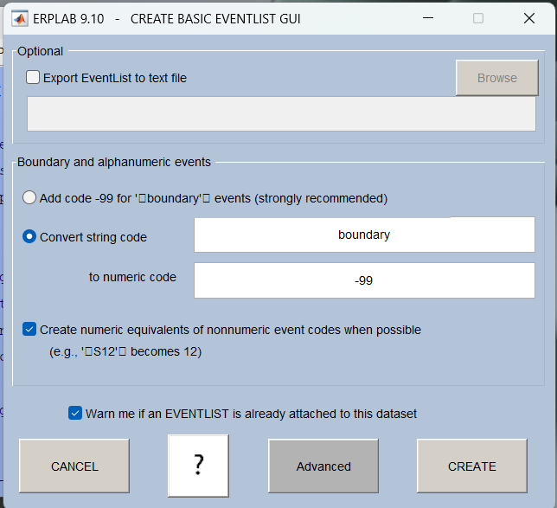

* 1. When done creating your event list, click apply which will populate another screen with “info to be used as event type.” Leave the selection as code labels and hit apply.
  2. Name the new dataset: cam###_block#_elist

1. ERPLab>Extract Bin-based Epochs
   1. Inputs: -200 1500 (Bin-based epoch time range ms), baseline correction: pre
   2. Click Run
   3. Name file as “cam###_block1_bepoch”
2. Plot>Channel Data (scroll) to make sure you events are labeled and appear
3. Artifact Detection and Rejection
   1. ERPLAB > Artifact detection in epoched data > Moving window peak-to-peak threshold
      1. Test period is based on the epoch you selected but uses the actual sample times so it may be slightly different
         1. Moving window: 100 ms (cannot be longer than epoch)
         2. Window step: 50 ms
         3. Take out: A2 in available channels

* + 1. Voltage threshold: a threshold of 100 to 250 microvolts should screen out most of the large artifacts.
       1. If data is messy, start at 250 and progress down to 100 to see how many trials gets rejected.
    2. Select a number under “mark flag” which will be used in the plot function to tell you what to reject
    3. Table

       Description automatically generatedThe total percentage of trials with artifacts detected and marked for rejection will show in the command window.
    4. Note how many trials were rejected in spreadsheet
    5. click “update marks” in the channel window that pops up
    6. Rename file as “cam###_block#_artrejthreshold#”
  1. Any artifacts marked in the dataset prior to artifact detection will remain marked when artifact rejection is performed on that dataset, and any additional artifacts will be marked in the new dataset. If you wish to unmark everything and start over, you can either clear the datasets and go back to an unmarked dataset or select ERPLAB > Artifact Detection > Clear Artifact Detection Marks
     1. Select “Reset Artifact Detection Marks”, “Reset Flags”, and “All Flags”
  2. Save artifact summary into participant file

Save as: cam###_block#_artifact rejection summary

1. File > save current data set as > in participants file cam###_block#_ready for erp

Or, just run this code in matlab.

addpath("C:\Users\path to subject data")

EEG.etc.eeglabvers = '2024.2'; % this tracks which version of EEGLAB is being used

EEG = pop_loadxdf('C:\Users\load to xdf file, 'streamtype', 'EEG', 'exclude_markerstreams', {});

EEG.setname='cam039_block3';

EEG=pop_chanedit(EEG, {'lookup', 'C:\Users\path to\eeglab2024.2\plugins\dipfit\standard_BEM\elec\standard_1005.elc'},'changefield',{20,'type','Ref'},'changefield',{21,'type','EMG'},'changefield',{22,'type','EMG'},'changefield',{23,'type','ACC'},'changefield',{24,'type','ACC'},'changefield',{25,'type','ACC'},'changefield',{26,'type','Misc'},'changefield',{27,'type','Misc'});

EEG.setname='subject#_block#_chanlocation';

eeglab redraw;

EEG = pop_eegfiltnew(EEG, 'locutoff',0.1,'hicutoff',50,'plotfreqz',1,'chantype',{'EEG'});

EEG.setname='cam039_block3_filt';

EEG = pop_select( EEG, 'rmchantype',{'ACC','EMG','Misc'});

EEG.setname='subject#_block#_chansremoved';

eeglab redraw;

%%%%%%%%%%% update channel locations manually %%%%%%%%%%%%%

%%%%%% manually trim plot to ignore prompts and misc task %%%%%%%%%%%%%

EEG = pop_reref( EEG, [],'exclude',20);

EEG.setname='subject#_block#_reref';

eeglab redraw;

%%%%%%%%%%% run ICA %%%%%%%%%%%%%%%%%%%%%

%%%%%%%% remove components %%%%%%%%%%%%%

%%%%% interpolate if needed %%%%%%%%%%%%%

%% create code for event numbers and epochs based on event %%

EEG = eeg_checkset( EEG );

EEG  = pop_editeventlist( EEG , 'AlphanumericCleaning', 'on', 'BoundaryNumeric', { -99}, 'BoundaryString', { 'boundary' }, 'List', 'C:\path to eventlist\eventlist.txt', 'SendEL2', 'EEG', 'UpdateEEG', 'askUser', 'Warning', 'on' );

EEG.setname='subject#_block#_elist';

EEG = pop_epochbin( EEG , [-200.0  1500.0],  'pre'); % GUI: 03-Mar-2039 13:49:43

EEG.setname='subject#_block#_bepoch';

eeglab redraw;

%% artifact rejection %%

EEG  = pop_artmwppth( EEG , 'Channel',  1:19, 'Flag', [ 1 8], 'LowPass',  -1, 'Threshold',  250, 'Twindow', [ -100 1400], 'Windowsize',  100, 'Windowstep',  50 );

EEG.setname='cam039_block3_artrej250';

EEG  = pop_artmwppth( EEG , 'Channel',  1:19, 'Flag', [ 1 7], 'LowPass',  -1, 'Threshold',  200, 'Twindow', [ -100 1400], 'Windowsize',  100, 'Windowstep',  50 );

EEG.setname='cam039_block3_artrej200';

EEG  = pop_artmwppth( EEG , 'Channel',  1:19, 'Flag', [ 1 6], 'LowPass',  -1, 'Threshold',  150, 'Twindow', [ -100 1400], 'Windowsize',  100, 'Windowstep',  50 );

EEG.setname='cam039_block3_artrej150';

%% saves data quality tables and create figures %%

EEG = pop_summary_AR_eeg_detection(EEG, 'C:\Users\path to\eeg\Data Quality\AR_summary_'subject#_block#__artrej150.txt');

pop_summary_rejectfields(EEG)

pop_summary_rejectfields(EEG)

pop_export(EEG,'C:\path to\PreProcessed\'subject#_block#_,'transpose','on','separator',',','precision',4);

pop_expevents(EEG, 'C:\Users\path to subject\PreProcessed\events_block#.txt', 'samples');

EEG = pop_saveset( EEG, 'filename','subject#_block#_ready for erp.set','filepath','C:\Users\path to subject\PreProcessed\');